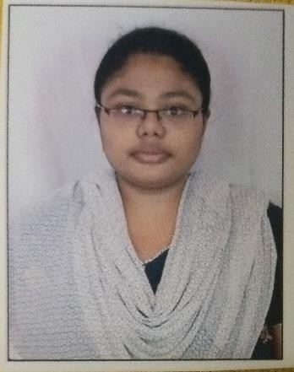
Curriculum Vitae Personal Information

Surname, Given Name: P, Arifa Begum
Date of Birth: 19th January 2000
University Degree: Bachelor of Technology (CSE) Marital Status: Single
Address: 944, Nethaji Nagar 1st Street Kottakarai, Gummidipoondi, Tamil Nadu - 60201
Email: arifabegum.p@gmail.com
Mobile: +91 7337000517

Experience Summary

I served in the Financial Services Banking Domain. My project work experience is majorly in the areas of Manual, System and Regression Testing. Having 4.5+ years of experience in the Banking and Financial services domain with expertise in Core Banking Applications.

Project Detail Summary

Project | Barclays Upgrade
Client | Barclays - US
Organization | FIS Global Business Solutions India Pvt. Ltd – Chennai
Role | Quality Assurance Analyst
Period | Oct 2025 - Till Date
Responsibilities | - Designed and executed test cases aligned with business requirements, ensuring high test coverage.  - Worked on the alert testing module.  - Gained Hands on Experience with Web Client Application (Mobile Banking Application)  - Identified, documented and tracked defects ensuring timely resolution and improved application quality.

Project | India Markets - Trade Finance
Client | BIDV - Myanmar
Organization | FIS Global Business Solutions India Pvt. Ltd – Chennai
Role | Quality Assurance Analyst
Period | April 2025 - Sep 2025
Responsibilities | - Designed and executed functional and system test cases based on business requirements.  - Performed end to end system testing including regression, integration and UAT support for multiple releases.  - Expertise all screens of the Trade Finance module. (LC, BG, Bills etc.)  - Conducted Sanity and Smoke Testing to ensure application stability and identify critical issues earlier.  - Actively participate in defect triage call with development team for timely resolution.  - Execution of test cases and track the defects in JIRA system.  - Conduct a retest of the resolved bug issues.  - Monitor and track the status of test defects until they are closed.  - Maintain accurate documentations for executed test programs.

Project | TISCO Xpress Profile - CR
Client | TISCO - Vietnam
Organization | FIS Global Business Solutions India Pvt. Ltd – Chennai
Role’s Handled | Quality Assurance Analyst
Period | Nov 2024 - Feb 2025
Responsibilities | - Participated individual member in SIT testing on the client environment using Soap UI tool.  - Prepared required test data for the CR.  - Create Test Cases and capture evidences for the executed test cases.  - Conducted one round of regression testing to avoid more issues in UAT.

Project | CAPEX
Client | FIS
Organization | FIS Global Business Solutions India Pvt. Ltd – Chennai
Role’s Handled | Quality Assurance Analyst
Period | Aug 2024 - April 2025
Responsibilities | - Redesigned and enhanced internal Core Banking system functionalities.  - Performed manual testing during code migration from legacy struct-based architecture to the Spring framework.  - Designed and executed functional, regression, and UI test cases to ensure application quality.  - Conducted comprehensive regression testing to validate system stability after changes.  - Collaborated closely with developers to identify, track, and resolve defects efficiently.

Project | National Bank of Pakistan (v7.6 Upgrade)
Client | NBPUPG – Pakistan
Organization | FIS Global Business Solutions India Pvt. Ltd – Chennai
Role | Quality Assurance Analyst
Period | April 2022 - July 2024
Responsibilities | - Gained strong understanding of new concepts within the Profile Core Banking System.  - Experienced in testing both Web-based and Windows-based applications, including WebCSR, WebAdmin, Profile, and Profile Direct Teller.  - Prepared detailed test data and test scenarios based on the Functional Specification Document (FSD).  - Investigated test issues, identified root causes, and implemented effective testing solutions.  - Conducted regression testing to ensure that new features and updates did not impact existing functionalities.  - Actively involved in all phases of testing for newly introduced project requirements.
Achievement | - Got On Spot Award for my Contribution towards the project.  - As a member of test support in NBP Team, I’ve been Recognized as the winners of Above & Beyond Q3,2024.

Certifications | - Completed Software Testing Course from Great Learning.  - Completed Python for Data Science and UI from Coursera.  - Completed Python for Data Structures from Coursera.

University Education

2017 – 2021 Bachelor of Technology – Computer Science & Engineering
SVEC Affiliated to JNTU University, Andhra Pradesh, India

technical Skills

Operating System | Software Testing Skills & Tools | Database
Putty | - Manual Testing  - Test Management  - STLC  - JIRA  - Agile  - Soap UI  - Test Rail | SQL

(Arifa Begum P)

